2.60: a) Simple subtraction and division gives average speeds during the 2-second
intervals as 5.6, 7.2 and 8.8 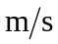.
b) The average speed increased by 1.6 during each 2-second interval, so the acceleration is 0.8 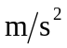.
c) From Eq. (2.13), with v₀ = 0, 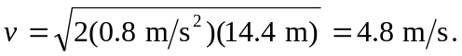 Or, recognizing that for constant acceleration the average speed of 5.6 m/s is the speed one second after passing the 14.4-m mark, 5.6 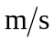 – (0.8 )(1.0 s) = 4.8 .
d) With both the acceleration and the speed at the 14.4-m known, either Eq. (2.8) or Eq. (2.12) gives the time as 6.0 s.
e) From Eq. (2.12), x – x₀ = (4.8 )(1.0 s) + (0.8 )(1.0 s)² = 5.2 m. This is also the average velocity (1/2)(5.6 + 4.8 ) times the time interval of
1.0 s.

